# Webpay Integration Sample

WebPay is a hosted payment solution that offers complete control over payment processing and customer experience without the costs and burden of security compliance. The WebPay Configuration page allows you to create and maintain your own payment forms hosted on our secure servers. From here you can control every aspect of the user interface and, using your own branding, deploy a seamless customer experience.

## Setting up the Webpay Form

Your test gateway account can set up sample Webpay forms. Choose “Webpay” from the menu on the left.

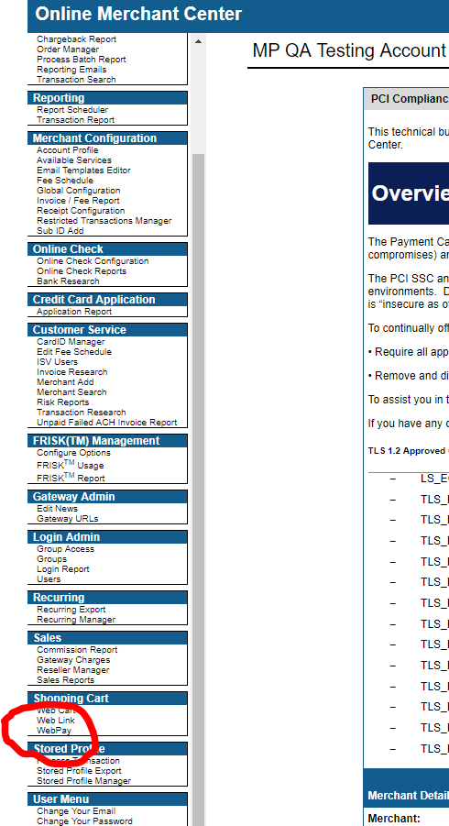

This will take you to the WebPay configuration screen. Here you can create Webpay forms for each transaction type you’d like to perform. Each form you create will have a unique URL you can direct customers to.

Choose the transaction type you’d like the Webpay page to perform from the “Payment Option” dropdown and give the form a meaningful name. The pages you’ve created will be listed in the “Edit Webpay Form” box. Click on your form’s name to open the Configuration screen.

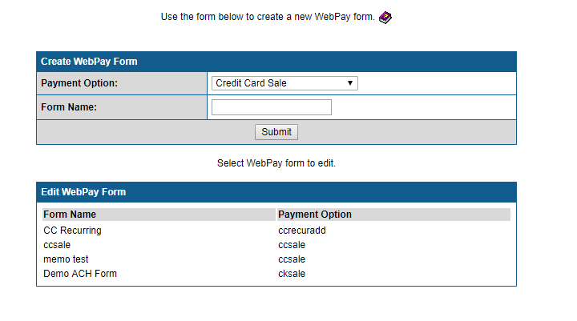

In the configuration screen you can set the “Host Domain” which will be the only domain your hosted page can link images from or redirect to.

The “Logo Path” should be located in the Host Domain and is where WebPay will look to find a logo to display. Your logo should be in Jpeg format to display in all browsers.

The “Post-back URL” is the URL our gateway will Post to after the transaction is processed. This should be the URL of a server that can receive receipt information. Make sure your server’s firewall settings allow it to accept Posts from our gateway.

## Customizing your WebPay form

A default Webpay form is created for you. If you “submit” the form now and follow the “WebPay URL” shown at the bottom of the Configuration screen you will see a form that looks like this:

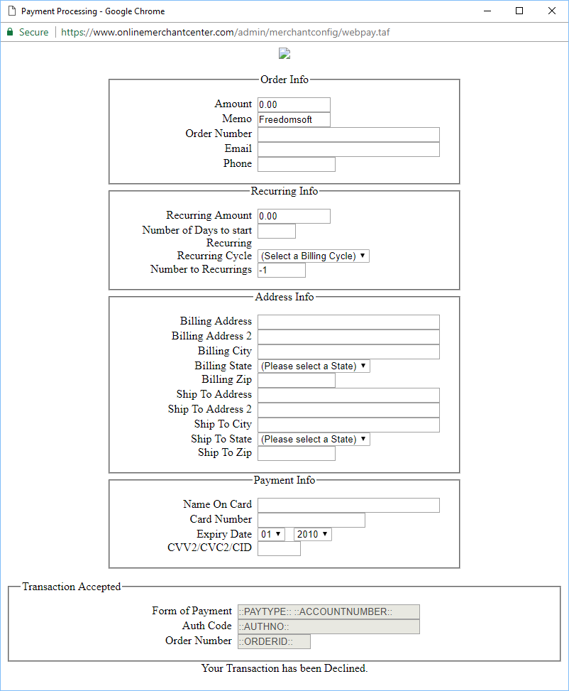

The default form includes many fields you may not want your customer to fill in or it may be missing something you’d like included. As a best practice, you’ll only want this form to include data you want sent through the gateway to the credit card processor. Click on the “Advanced” tab in the configuration screen to customize your WebPay form.

The form’s HTML is in the “Form” window. Only certain labels will be recognized by the gateway. For example,

<span class="webpay">

<label for="amount" class="webpay">Amount</label><input alt="" name="amount" class="webpay" type="text" value="::AMOUNT::" size="10" >

</span>

Will fill in the “Amount” field in the gateway’s request. However,

<span class="webpay">

<label for="sale_amount" class="webpay">Amount</label><input alt="" name="sale_amount" class="webpay" type="text" value="::AMOUNT::" size="10" >

</span>

Will be ignored by the gateway and your request will be missing a required field.

Fields in this form can and should be pre-filled with the information you’ve gathered before redirecting customers to the payment screen. This information is passed through the URL. Instructions for customizing the URL to include your transaction data can be found in the Webpay Integration guide.

### Important notes for WebPay customization

* You can include HTML and inline CSS in your Form code. Any JavaScript or links to a CSS file will be redacted by the gateway.
* Your page can only redirect to locations in the Host Domain that you set at the top of the page.
* Images should be in Jpeg format to display in all browsers.
* Click “Submit” at the bottom of the page to update any changes you make.
* A 3DES key must be generated for the account before your page can display. You won’t need to use the key anywhere in the page but you will need to create one. The 3DES key can be generated in FRISK Management -> Configure Options -> Account Number 3DES Encryption -> Edit